HAD LAB INTENT

SOHAN M
1NT19IS155

XML Activity-1

<?xml version="1.0" encoding="utf-8"?>
<androidx.constraintlayout.widget.ConstraintLayout xmlns:android="http://schemas.android.com/apk/res/android"
xmlns:app="http://schemas.android.com/apk/res-auto"
xmlns:tools="http://schemas.android.com/tools"
android:layout_width="match_parent"
android:layout_height="match_parent"
tools:context=".MainActivity">
<Button
android:id="@+id/click"
android:layout_width="253dp"
android:layout_height="62dp"
android:text="CLICK"
app:layout_constraintBottom_toBottomOf="parent"
app:layout_constraintEnd_toEndOf="parent"
app:layout_constraintHorizontal_bias="0.498"
app:layout_constraintStart_toStartOf="parent"
app:layout_constraintTop_toBottomOf="@+id/name"
app:layout_constraintVertical_bias="0.332" />
<EditText
android:id="@+id/name"
android:layout_width="364dp"
android:layout_height="88dp"
android:text="Enter Your Name"
android:gravity="center"
android:textSize="40dp"
app:layout_constraintBottom_toBottomOf="parent"
app:layout_constraintHorizontal_bias="0.459"
app:layout_constraintLeft_toLeftOf="parent"
app:layout_constraintRight_toRightOf="parent"
app:layout_constraintTop_toTopOf="parent"
app:layout_constraintVertical_bias="0.29" />
</androidx.constraintlayout.widget.ConstraintLayout>

Controller Activity 1

package com.example.intent;
import androidx.appcompat.app.AppCompatActivity;
import android.content.Intent;
import android.os.Bundle;
import android.view.View;
import android.widget.Button;
import android.widget.EditText;
public class MainActivity extends AppCompatActivity {
EditText name;
Button click;
@Override
protected void onCreate(Bundle savedInstanceState) {
super.onCreate(savedInstanceState);
setContentView(R.layout.activity_main);
name = findViewById(R.id.name);
click = findViewById(R.id.click);
click.setOnClickListener(new View.OnClickListener() {
@Override
public void onClick(View v) {
Intent it = new Intent(MainActivity.this,MainActivity2.class);
Bundle b = new Bundle();
b.putString("name",name.getText().toString());
it.putExtras(b);
startActivity(it);
}
});
}
}

XML Activity-2

<?xml version="1.0" encoding="utf-8"?>
<androidx.constraintlayout.widget.ConstraintLayout xmlns:android="http://schemas.android.com/apk/res/android"
xmlns:app="http://schemas.android.com/apk/res-auto"
xmlns:tools="http://schemas.android.com/tools"
android:layout_width="match_parent"
android:layout_height="match_parent"
tools:context=".MainActivity2">
<TextView
android:id="@+id/myname2"
android:layout_width="221dp"
android:layout_height="103dp"
android:text="TextView"
android:textSize="45dp"
android:gravity="center"
app:layout_constraintBottom_toBottomOf="parent"
app:layout_constraintEnd_toEndOf="parent"
app:layout_constraintStart_toStartOf="parent"
app:layout_constraintTop_toTopOf="parent" />
</androidx.constraintlayout.widget.ConstraintLayout>

Controller Activity 2

package com.example.intent;
import android.os.Bundle;
import android.widget.TextView;
import androidx.appcompat.app.AppCompatActivity;
public class MainActivity2 extends AppCompatActivity {
@Override
protected void onCreate(Bundle savedInstanceState) {
TextView myname2;
String temp_name;
super.onCreate(savedInstanceState);
setContentView(R.layout.activity_main2);
myname2 = findViewById(R.id.myname2);
temp_name = getIntent().getStringExtra("name");
myname2.setText(temp_name);
}
}

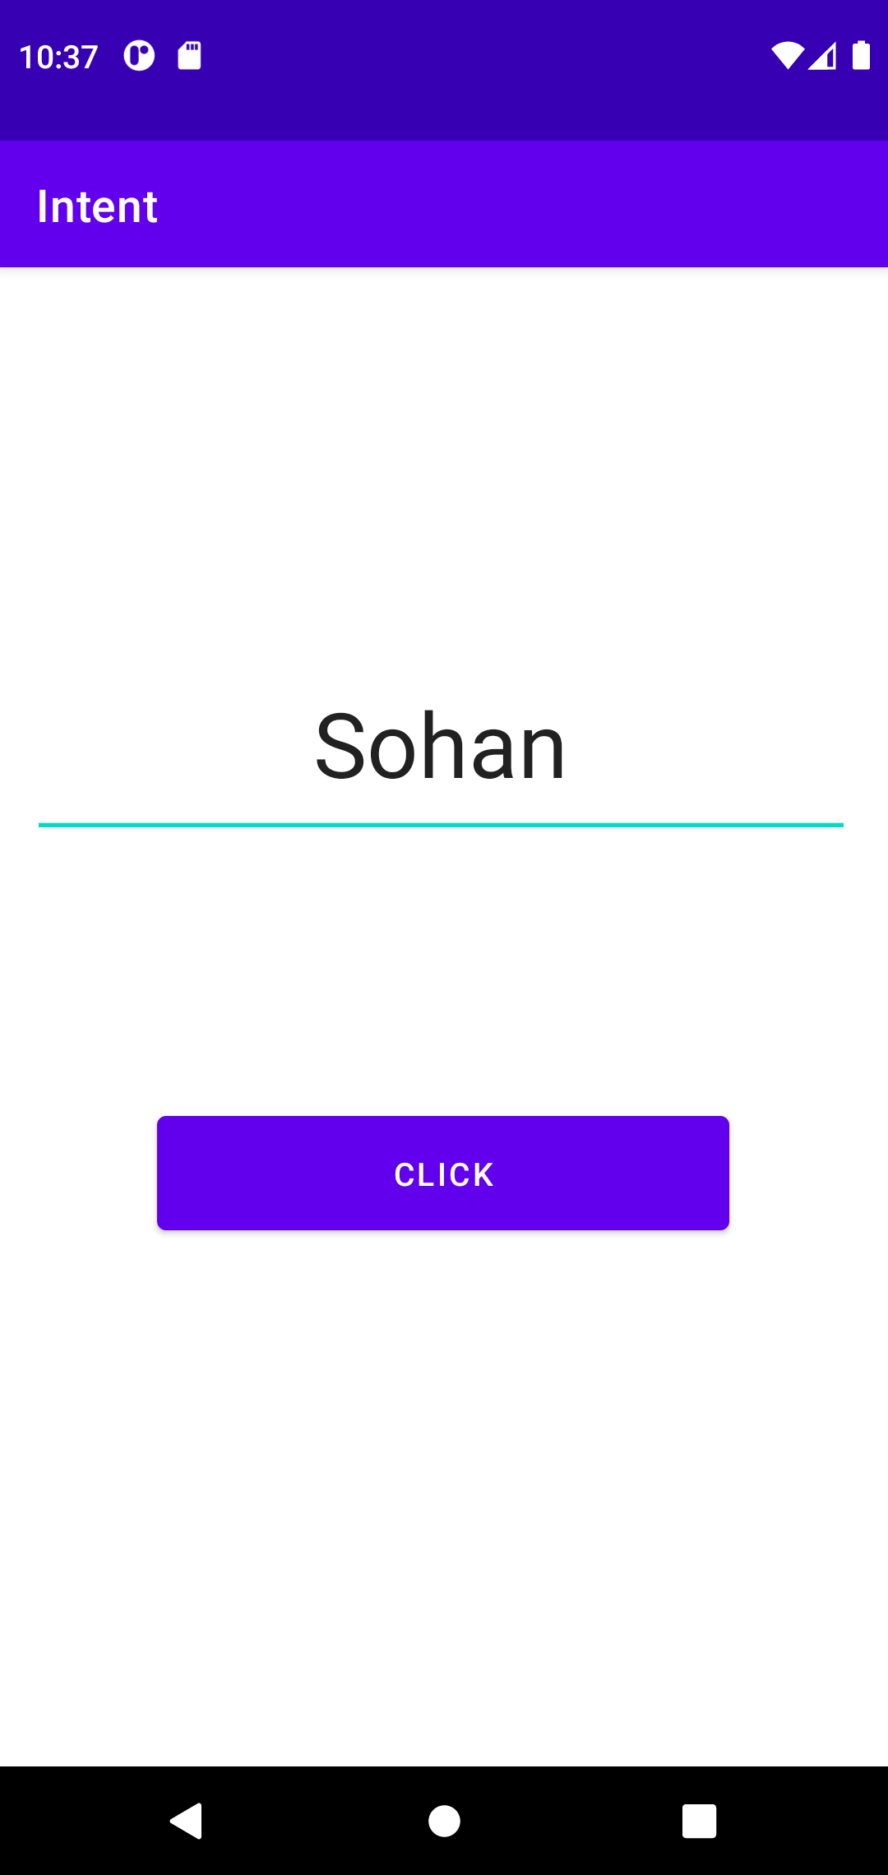
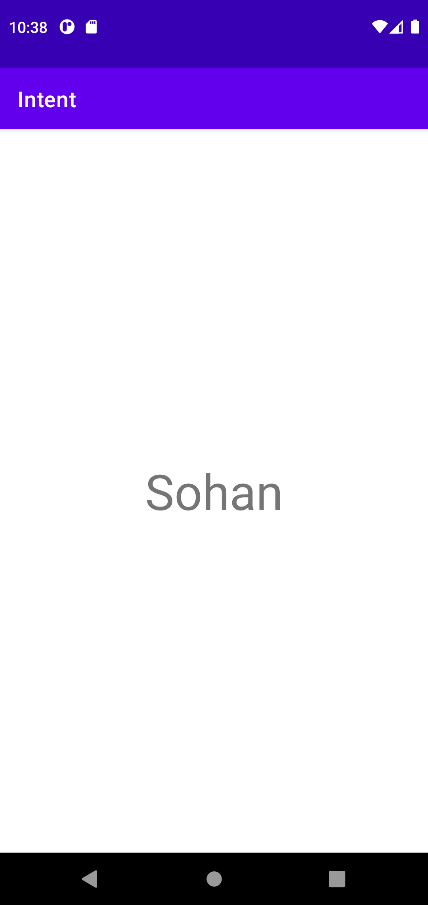

Explicit

Xml Activity

<?xml version="1.0" encoding="utf-8"?>
<androidx.constraintlayout.widget.ConstraintLayout xmlns:android="http://schemas.android.com/apk/res/android"
xmlns:app="http://schemas.android.com/apk/res-auto"
xmlns:tools="http://schemas.android.com/tools"
android:layout_width="match_parent"
android:layout_height="match_parent"
tools:context=".MainActivity">
<EditText
android:id="@+id/call"
android:layout_width="wrap_content"
android:layout_height="wrap_content"
android:hint="Enter Mobile No"
android:textSize="30dp"
android:gravity="center"
android:backgroundTint="@color/purple_200"
android:ems="10"
android:inputType="phone"
app:layout_constraintBottom_toBottomOf="parent"
app:layout_constraintEnd_toEndOf="parent"
app:layout_constraintHorizontal_bias="0.497"
app:layout_constraintStart_toStartOf="parent"
app:layout_constraintTop_toTopOf="parent"
app:layout_constraintVertical_bias="0.432" />
<Button
android:id="@+id/button"
android:layout_width="251dp"
android:layout_height="63dp"
android:text="Make a Call"
android:textSize="25dp"
app:layout_constraintBottom_toBottomOf="parent"
app:layout_constraintEnd_toEndOf="parent"
app:layout_constraintHorizontal_bias="0.498"
app:layout_constraintStart_toStartOf="parent"
app:layout_constraintTop_toBottomOf="@+id/call"
app:layout_constraintVertical_bias="0.274" />
</androidx.constraintlayout.widget.ConstraintLayout>
Java File

package com.example.explicit;
import android.content.Intent;
import android.net.Uri;
import android.os.Bundle;
import android.view.View;
import android.widget.Button;
import android.widget.EditText;
import android.widget.Toast;
import androidx.appcompat.app.AppCompatActivity;
import android.os.Bundle;
public class MainActivity extends AppCompatActivity {
@Override
protected void onCreate(Bundle savedInstanceState) {
super.onCreate(savedInstanceState);
setContentView(R.layout.activity_main);
Call();
}
private void Call() {
Button btn = findViewById(R.id.button);
btn.setOnClickListener(new View.OnClickListener() {
@Override
public void onClick(View v) {
EditText e = findViewById(R.id.call);
String show = e.getText().toString();
Toast.makeText(MainActivity.this, "You typed "+show, Toast.LENGTH_SHORT).show();
Uri u = Uri.parse("tel:"+show);
Intent i = new Intent(Intent.ACTION_DIAL,u);
try {
startActivity(i);
}
catch (SecurityException s){
Toast.makeText(MainActivity.this, "An Error occurred", Toast.LENGTH_SHORT).show();
}
}
});
}
}

